Name : Vishal Jha

Batch : Data Engineering

Date : 21-02-2024

Topic : Azure Databricks Coding Challenge – 01

1. Exploratory data analysis (EDA) in Databricks &Visualizing data in Databricks.
2. First created Azure Databricks Workspace.

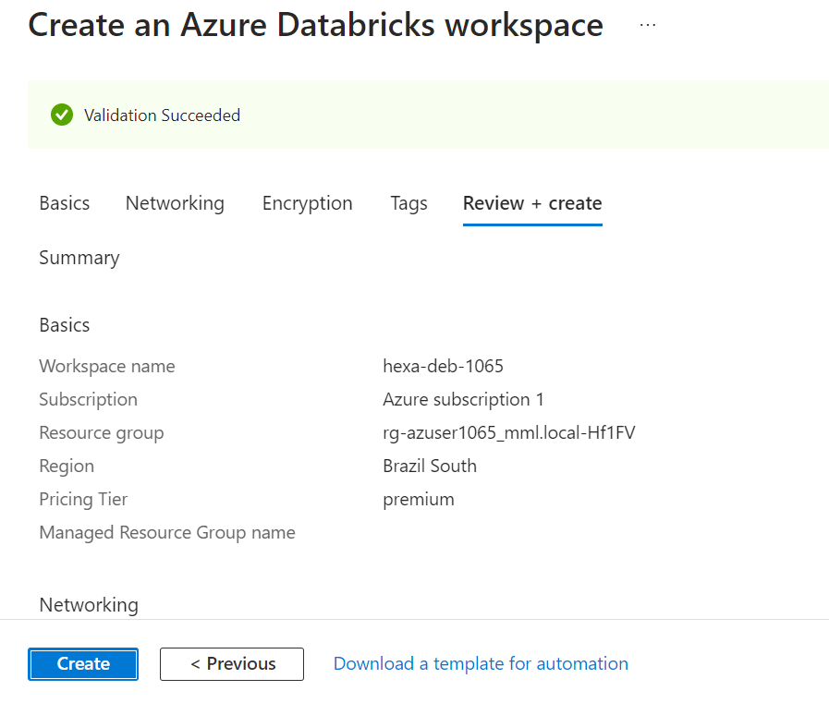

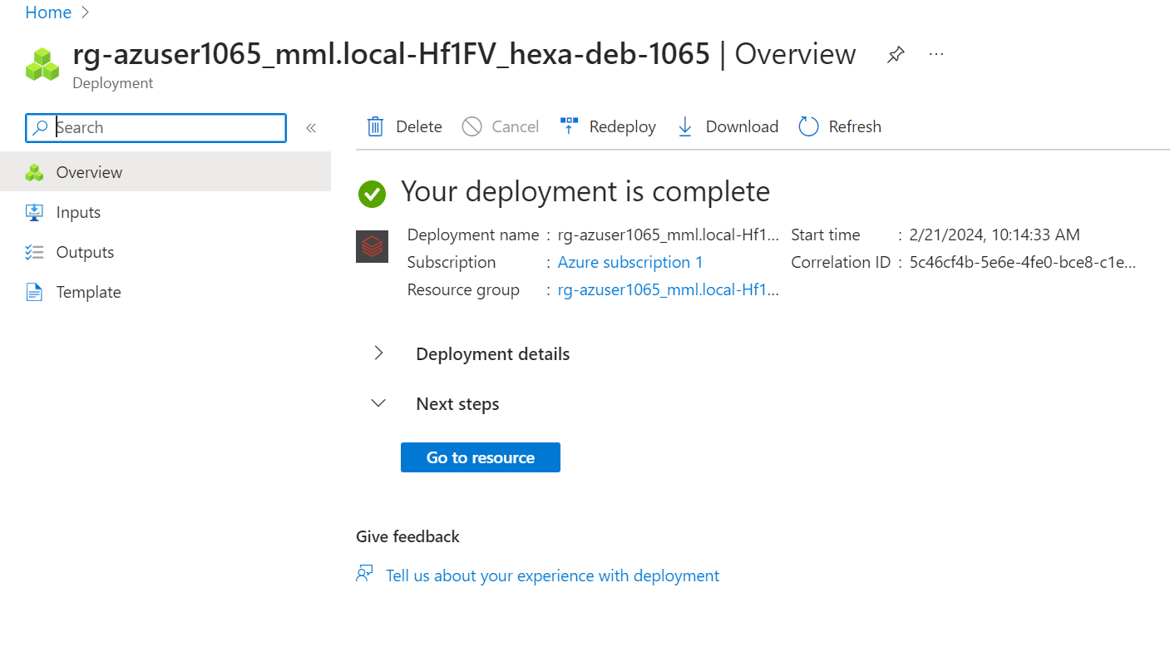

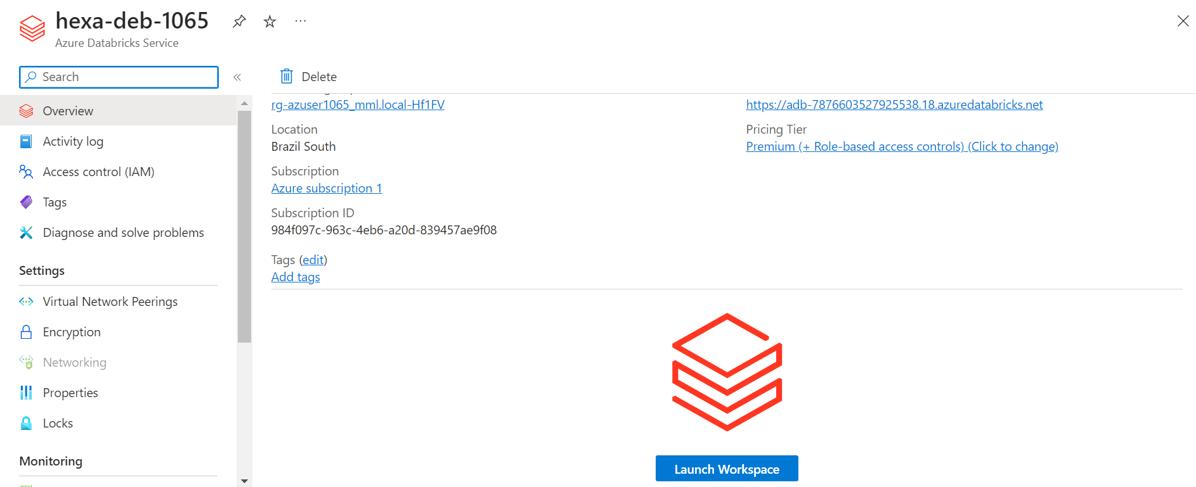

1. Creating Cluster.

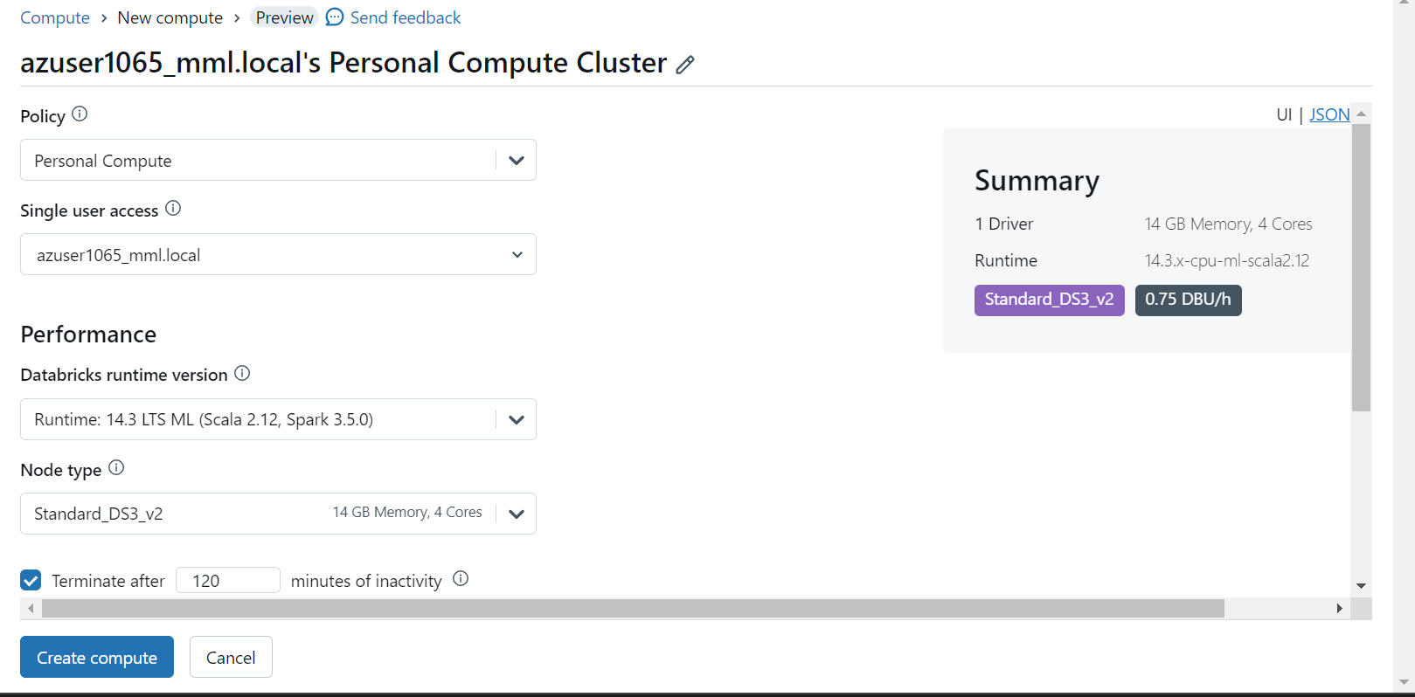

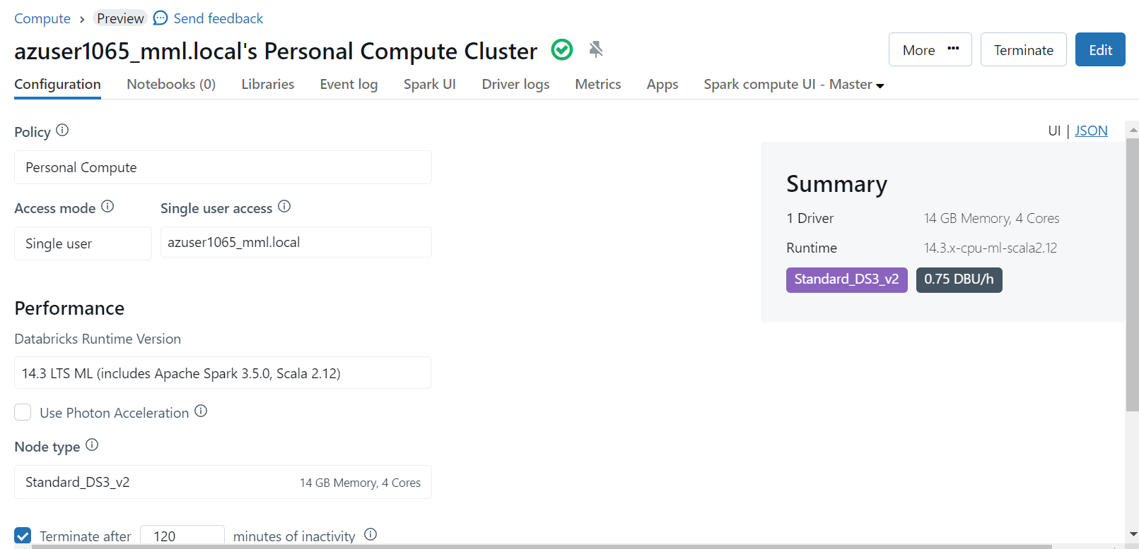

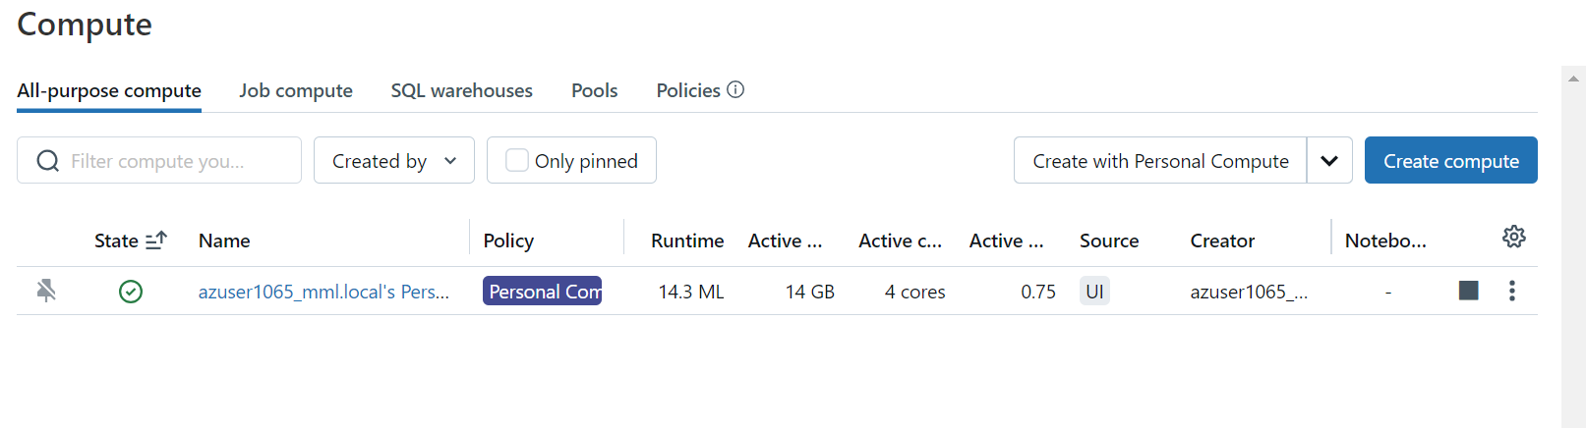

1. Creating Notebook and Connecting it with Cluster.

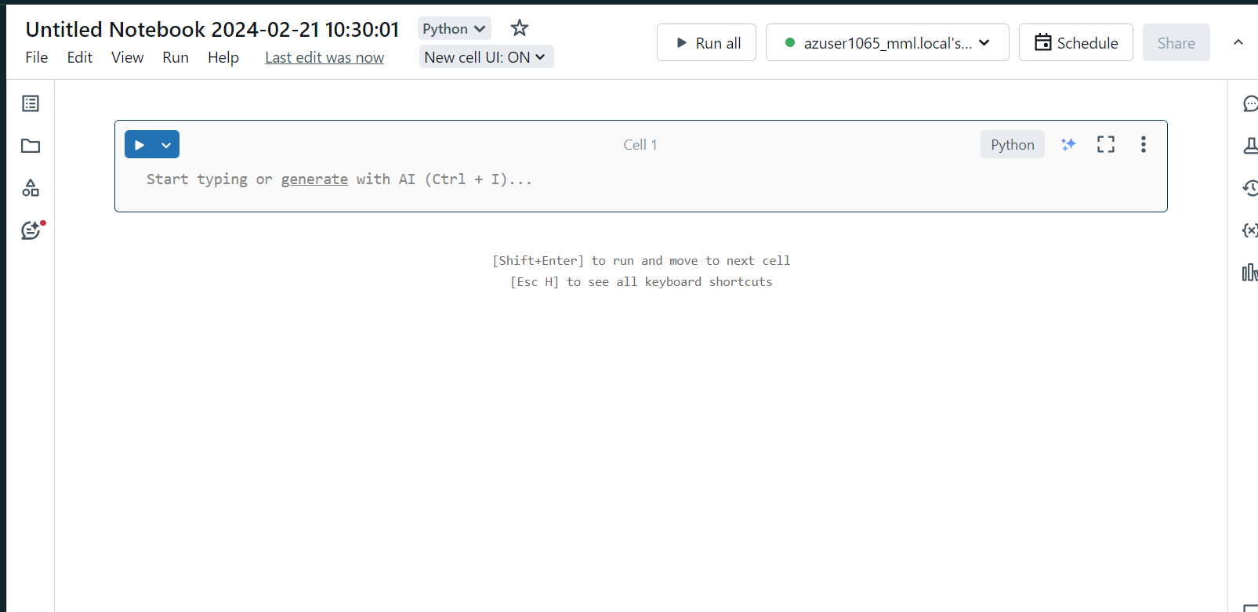

1. Running code for Exploratory Data Analysis

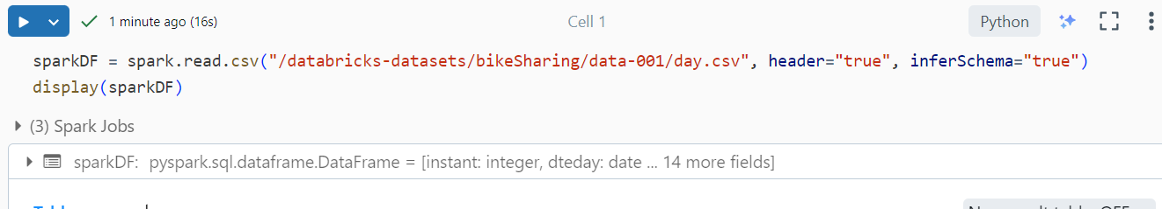

Output of Exploratory Data Analysis:

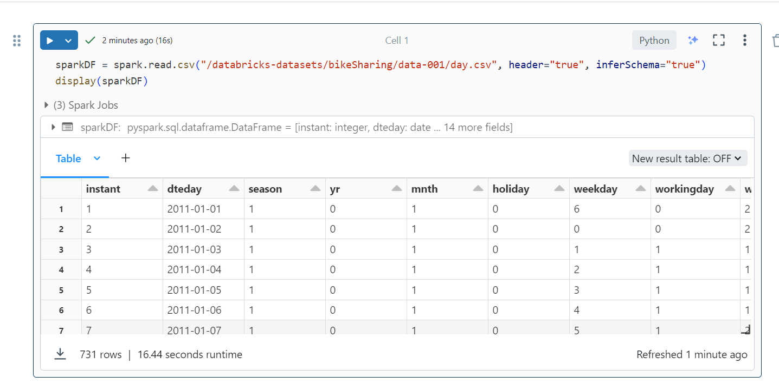

1. Creating Visualization for above Exploraroty Data Analysis.

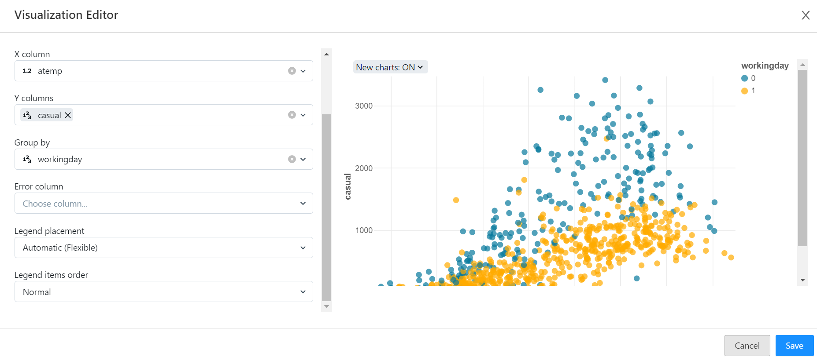

Output of Visualization:

